AI Traffic Moderator
*Note: Sub-titles are not captured in Xplore and should not be used

Poorva Chougule  Dept. of Computer Engineering  Marathwada Mitra Mandal’s College of Engineering Pune, India  poorvachougule2023.comp@mmcoe.edu.in | Manaswin Sripatnala  Dept. of Computer Engineering  Marathwada Mitra Mandal’s College of Engineering Pune, India  manaswinsripatnala2023.comp@mmcoe.edu.in |  | Niel Mandhare  Dept. of Computer Engineering  Marathwada Mitra Mandal’s College of Engineering Pune, India  nielmandharae2023.comp@mmcoe.edu.in
Tanushka Chavan  Dept. of Computer Engineering  Marathwada Mitra Mandal’s College of  Engineering Pune, India  tanushkachavan2023.comp@mmcoe.edu.in |  | Mayuri Narkhede  Dept. of Computer Engineering  Marathwada Mitra Mandal’s College of  Engineering Pune, India  mayurinarkhede@mmcoe.edu.in

Abstract - Urban traffic, especially on single-lanes, has become a severe challenge due to increase in the vehicle density and insufficient signal timing. Traditional signal system runs on fixed time cycles which leads to delays and road hindrance during peak hours. To handle this problem, this research paper presents an AI-driven real time traffic management system that dynamically changes the signal based on road conditions. The system relies on real-time video analysis, applying the YOLO algorithm for fast and precise object detection. YOLO integrated with python uses live camera feed to detect and count the number of vehicles frame by frame. Depending on the count of vehicles and traffic density the signals are adjusted dynamically.

Keywords - AI-based Traffic Management, Real-time Signal Control, YOLO Object Detection, Vehicle Density Analysis, Dynamic Traffic Signal System.
I. INTRODUCTION
Traffic congestion has emerged as a critical challenge in modern urban environments, particularly in developing countries where rapid urbanization and increasing vehicle density exert significant pressure on existing transportation infrastructure [1], [6]. Conventional traffic signal systems primarily operate on fixed timing cycles, which are unable to adapt to dynamic traffic conditions, resulting in increased vehicle waiting time, inefficient fuel consumption, and elevated levels of air pollution [2].
Recent advancements in artificial intelligence (AI) and computer vision have enabled the development of intelligent traffic management systems capable of analyzing real-time traffic data and dynamically adjusting signal timings [3], [4]. Deep learning-based approaches, particularly object detection models such as YOLO (You Only Look Once), have demonstrated high accuracy and efficiency in real-time vehicle detection tasks, making them highly suitable for traffic monitoring applications [11], [12]. Furthermore, modern intelligent transportation systems incorporate machine learning and IoT-based solutions to improve traffic flow, reduce congestion, and enhance overall road safety [10], [13].
Despite these advancements, most existing solutions are designed for large-scale, multi-lane intersections and often rely on expensive infrastructure, cloud-based processing, or high-end computational resources [9]. Such approaches are not always feasible for deployment in smaller urban areas, residential zones, or single-lane roads, where traffic conditions differ significantly and budget constraints limit large-scale implementation. Additionally, many systems focus on prediction rather than real-time responsiveness, which can limit their effectiveness in rapidly changing traffic scenarios.
To address these limitations, this paper proposes an AI-driven real-time traffic management system specifically designed for single-lane road environments. The proposed system utilizes live video input from surveillance cameras and applies the YOLOv8 object detection model to identify and count vehicles in real time. Based on the observed traffic density, an adaptive signal control mechanism dynamically adjusts traffic light states (RED, YELLOW, GREEN) to optimize traffic flow and reduce congestion. The system is implemented using Python and OpenCV for video processing, along with lightweight backend architecture for efficient real-time operation.
The key contribution of this work lies in the development of a cost-effective, lightweight, and scalable traffic control solution that operates efficiently on standard computing devices without requiring complex infrastructure. Unlike traditional fixed-timing systems, the proposed approach emphasizes real-time adaptability and practical deployment in resource-constrained environments. Additionally, the system provides real-time visualization of traffic patterns, enabling improved monitoring and data-driven decision-making.
The remainder of this paper is organized as follows: Section II presents the literature review, Section III describes the proposed methodology, Section IV discusses the system architecture and implementation, Section V presents the results and performance evaluation, and Section VI concludes the paper with future research directions.
II. LITERATURE REVIEW
Recent advancements in intelligent transportation systems have led to the development of various AI-based traffic management approaches aimed at improving traffic flow and reducing congestion. Researchers have explored machine learning, deep learning, and IoT-based techniques to design adaptive traffic signal systems.
Bajaj [1] investigates machine learning models such as Random Forest, Decision Trees, and Support Vector Machines (SVM) for traffic prediction using camera data. The study highlights that Random Forest provides better performance in congestion prediction; however, the model lacks generalization across different regions and depends heavily on high-quality datasets.
Deep learning-based approaches have gained significant attention in recent years. Shelar et al. [2] utilizes YOLOv8 for real-time vehicle detection and adaptive signal control, improving traffic flow and reducing congestion, though requiring high computational resources. Similarly, Sultana et al. [3] integrate AI with IoT for real-time monitoring and emergency response, enhancing mobility but increasing system complexity and infrastructure dependency.
Machine learning-based adaptive signal systems have also been explored. Genitha et al. [4] propose a system that optimizes signal timing based on traffic density, improving flow and reducing waiting time, although its effectiveness depends on data quality. Nasim et al. [5] provides a comprehensive review of AI techniques in traffic management, highlighting challenges such as data scarcity, infrastructure limitations, and model reliability.
Chavan et al. [6] analyze intelligent traffic management systems in the Indian context, identifying key challenges such as heterogeneous traffic conditions and infrastructure limitations. Goenawan [7] proposes a hybrid deep learning model combining YOLOv5 and LSTM for traffic detection and prediction, achieving high accuracy but requiring substantial computational resources.
Advanced deep learning models have further improved traffic management capabilities. Karthik et al. [8] presents a CNN-based system that enhances detection accuracy and reduces congestion but depends on GPU-based processing. Zhang et al. [9] review reinforcement learning-based traffic signal control methods, demonstrate improved traffic throughput and reduced waiting times, although training complexity remains a limitation.
Hybrid IoT and AI systems have also been widely studied. Kumar et al. [10] propose an IoT-AI-based traffic monitoring system that improves efficiency and safety but relies heavily on sensor reliability and infrastructure support. Foundational object detection models such as YOLOv3 [11] and YOLOv4 [12] have significantly contributed to real-time detection capabilities, enabling faster and more accurate vehicle recognition in traffic environments.
Rahman et al. [13] present a deep learning-based traffic management system that enhances monitoring and control, while Wang et al. [14] explore edge computing for real-time traffic analysis in smart cities, improving processing efficiency and reducing latency. Additionally, Ma et al. [15] utilize LSTM-based models for traffic prediction, demonstrating improved forecasting accuracy but requiring large datasets and computational resources.
Despite these advancements, most existing systems are designed for large-scale, multi-lane intersections and require significant infrastructure or computational resources. Limited research focuses on lightweight, cost-effective solutions tailored for single-lane traffic scenarios with real-time responsiveness. This gap motivates the proposed system, which aims to provide an efficient, scalable, and real-time traffic management solution using computer vision and adaptive signal control.
III. METHODOLOGY
The proposed system follows a pipeline-based architecture for real-time traffic signal control. The methodology encompasses five core modules: video acquisition, frame extraction, object detection, vehicle counting, and adaptive signal control. Figure 1 illustrates the skeletal functionality of the model and Figure 2 presents the system flowchart.
A. Video Input and Frame Extraction
The system acquires a continuous live video stream from a traffic surveillance camera positioned at an intersection. The incoming stream is decomposed into discrete sequential frames, each of which is independently processed for vehicle detection. This frame-level decomposition enables real-time analysis by reducing the computational complexity associated with processing continuous video data, ensuring low-latency response suitable for dynamic traffic environments.
B. Object Detection Using YOLO
Each extracted frame is passed through the YOLOv8 (You Only Look Once) object detection model, developed by Ultralytics. YOLO is a single-stage deep learning detector that performs bounding box regression and class prediction simultaneously in a single forward pass, making it well-suited for real-time applications. The model is pre-trained on the COCO dataset and configured to detect four vehicle categories: cars, motorcycles, buses, and trucks. Non-vehicle detections are filtered out to ensure that only traffic-relevant objects contribute to downstream processing.
C. Vehicle Counting Module
Following object detection, the system enumerates the total number of vehicles identified within each frame. This count serves as the primary quantitative metric for evaluating traffic density at the intersection. The vehicle count is continuously updated with each processed frame, providing a dynamic and accurate representation of real-time traffic conditions.
D. Adaptive Signal Control Logic
The signal decision module implements a threshold-based adaptive control strategy driven by the vehicle count obtained from the detection module. The control logic operates as follows:
- When the vehicle count exceeds 10, the signal transitions to GREEN, indicating high traffic density requiring immediate clearance.
- When the vehicle count falls between 5 and 10, the signal is set to YELLOW, representing moderate traffic density requiring caution.
- When the vehicle count is below 5, the signal remains RED, indicating low traffic density where flow is not warranted.
Each signal phase is governed by a timer-based cycle to prevent rapid state oscillation and ensure stable, predictable signal behaviour. This adaptive mechanism eliminates the inefficiencies of fixed-time signal controllers by dynamically responding to observed traffic conditions.

E. Real-Time Visualization and Monitoring
To facilitate system monitoring and performance analysis, the proposed system incorporates a real-time data visualization module. Vehicle count data is continuously plotted on a time-series graph, maintaining a rolling window of recent observations. This dashboard provides traffic operators with actionable insights into traffic flow trends, system responsiveness, and historical patterns within a session, indicated in Fig.1. The live annotated video feed is simultaneously rendered alongside the signal status, offering a comprehensive operational interface for traffic management personnel.

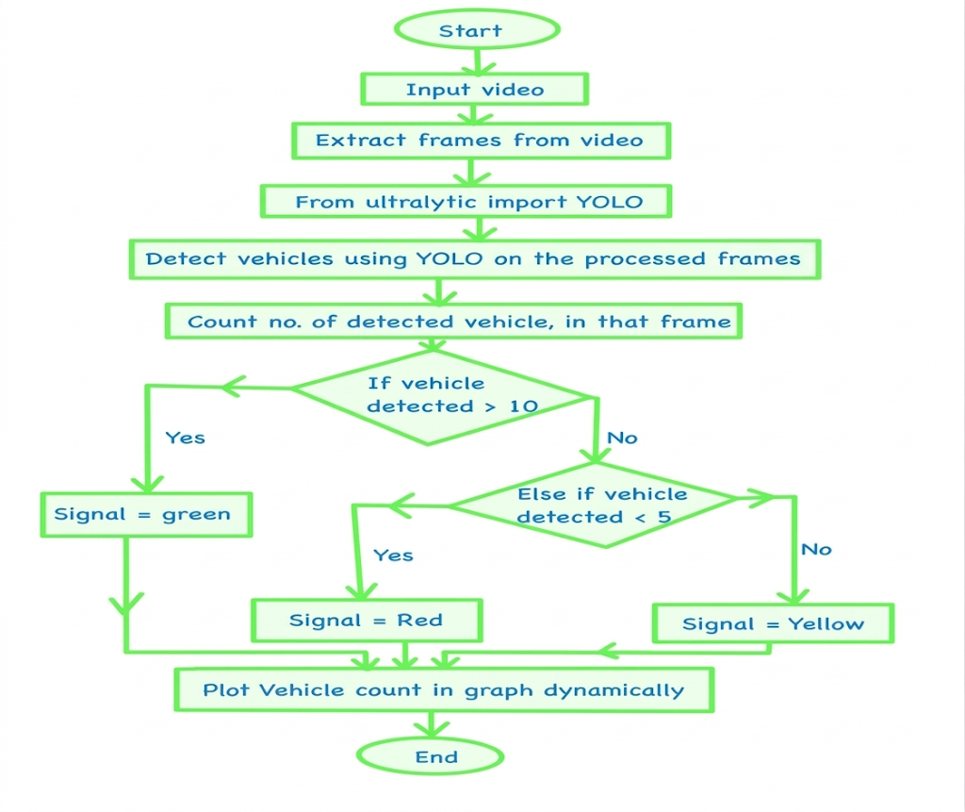
Fig. 1. Skeletal Functionality of model
IV. ALGORITHMS AND TECHNOLOGY
A. YOLO Object Detection Algorithm
The You Only Look Once (YOLO) algorithm serves as the core detection engine in the proposed system. Unlike traditional multi-stage detectors, YOLO performs object localization and classification in a single forward pass through the network, making it particularly suitable for real-time traffic monitoring applications. The algorithmic pipeline is described as follows:
1. Input and Preprocessing
The system accepts individual video frames as input images. Prior to inference, each frame undergoes preprocessing which includes resizing to the required input dimensions (e.g., 416×416 pixels) and normalization of pixel intensity values to a standardized range, ensuring consistent model performance across varying lighting and environmental conditions.
2. Grid-Based Spatial Decomposition
The pre-processed image is divided into an S×S grid of cells. Each cell is independently responsible for detecting objects whose centres fall within its spatial boundary. This grid-based decomposition allows the model to reason about multiple objects across different spatial regions of the image simultaneously.
3. Bounding Box Prediction
Each grid cell predicts B bounding boxes along with associated confidence scores. Every bounding box is characterized by five parameters: the centre coordinates (x, y) relative to the grid cell, the width and height (w, h) normalized with respect to the full image dimensions, and a confidence score. The confidence score quantifies the model's certainty that a bounding box contains an object of interest, expressed as a scalar value between 0 and 1. Each grid cell additionally predicts a probability distribution over all target object classes.
4. Final Score Computation
The final detection score for each bounding box is computed as the product of the predicted class probability and the associated confidence score. This joint score reflects both the likelihood of object presence and the accuracy of class assignment, enabling reliable discrimination between vehicle and non-vehicle detections.
5. Non-Maximum Suppression (NMS)
To eliminate redundant and overlapping detections, Non-Maximum Suppression is applied as a post-processing step. Among all bounding boxes predicted for the same object, only the box with the highest confidence score is retained, while all overlapping boxes exceeding a defined Intersection over Union (IoU) threshold are discarded. This ensures that each physical vehicle in the scene corresponds to exactly one detection output.
6. Output
The final output consists of detected objects annotated with bounding box coordinates, class labels (e.g., car, motorcycle, bus, truck), and confidence scores, which are subsequently passed to the vehicle counting module.
B. Application in the Proposed System
In the context of this work, the YOLOv8n model — a lightweight variant of the YOLOv8 architecture developed by Ultralytics — is deployed for real-time vehicle detection from live video streams. The detected vehicle count per frame is used to estimate traffic density at the monitored intersection, which in turn drives the adaptive signal control logic. All model inference, frame processing, and signal decision logic are implemented in Python.
C. Libraries and Frameworks
The system is developed on the prerequisite software components indicated in Table-1

Component | Purpose
Ultralytics YOLOv8 | Real-time object detection and vehicle classification
OpenCV | Live video capture and frame extraction
Flask | Backend REST API and MJPEG video streaming
React.js + Chart.js | Frontend dashboard and real-time graph visualization
React Leaflet | Interactive map interface using OpenStreetMap tiles
Axios | HTTP communication between frontend and backend
Table 1. Prerequisites
2. Data Flow Architecture
The end-to-end data flow of the system follows a sequential pipeline as illustrated in Fig.2

Camera → Frame Extraction → YOLO Detection → Vehicle Counting → Signal Decision → Dashboard Visualization

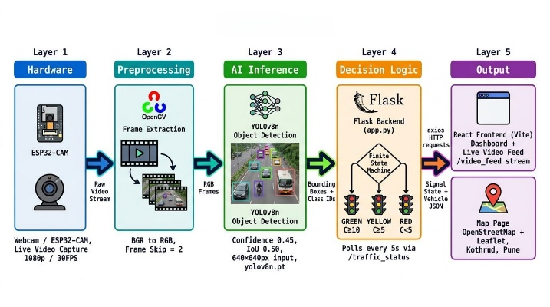
Fig. 2 System Architecture
Each stage in the pipeline operates in a continuous loop, processing successive frames in real time to maintain up-to-date signal states and traffic statistics throughout system operation.
3. Signal Control Logic
The signal decision module employs a rule-based control strategy derived from observed vehicle density. The mapping between traffic density and signal state depicted in Table-2

Vehicle Count | Signal State | Description
≥ 10 | GREEN | High density — clearance required
5 – 9 | YELLOW | Moderate density — caution mode
< 5 | RED | Low density — flow not warranted
Table 2. Signal States
This threshold-driven approach provides a deterministic and interpretable control mechanism that can be readily extended with machine learning-based predictive models in future iterations of the system. The backend logic is shown in the Fig. 3, whereas Fig. 4. Represents the Flowchart of working model and the implementation parameters are described in Table-3.

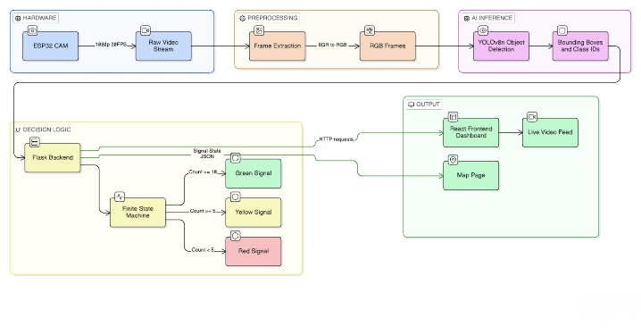
Fig. 3. Backend Logic

Table 3. Implementation parameters
Parameter | Default Value | Rationale
YOLO Model File | yolov8n.pt | Pre-trained YOLOv8 nano weights; optimal speed/accuracy for edge hardware
Frame Skip | 2 | Processes every 2nd frame; reduces CPU load by ~50%
SMA Window (N) | 5 frames | Smooths count fluctuations from transient occlusions or lighting changes
GREEN Threshold | C ≥ 10 vehicles | High density; opens signal to clear congestion for 30 s
YELLOW Threshold | 5 ≤ C < 10 vehicles | Moderate density: caution phase prepares for transition, 10 s
RED Threshold | C < 5 vehicles | Low density; holds signal to conserve green time, 20 s
Min Dwell Time (T_min) | 5 s | Prevents rapid signal oscillation (hysteresis)
GREEN Phase Duration | 30 s | Extended green window to clear high-density traffic
YELLOW Phase Duration | 10 s | Short caution buffer between green and red
RED Phase Duration | 20 s | Hold period during low-density conditions
Backend Framework | Flask (Python) | Lightweight local server owns webcam, runs YOLO, manages signal state
Video Stream Endpoint | /video_feed | Persistent MJPEG stream served via Flask to React frontend
Status Poll Endpoint | /traffic_status | Returns signal colour + vehicle count as JSON; polled every 5 s
Frontend Framework | React (Vite) / HTML5 | Display layer; renders live video feed, traffic light component, and chart
Map Library | Leaflet.js + OpenStreetMap | Open source, no API key required; pinned to deployment location
HTTP Client | Axios | Handles polling requests from React frontend to Flask backend
Video Capture API | cv2.VideoCapture() | Grabs frames from webcam or ESP32-CAM via USB / RTSP
Detection Classes | Car (2), Motorcycle (3), Bus (5), Truck (7) | COCO dataset class IDs filtered from YOLO output
Hardware Platform | PC / Raspberry Pi 4 (4 GB RAM) | Local edge deployment; no cloud dependency
Camera Module | Webcam / ESP32-CAM | Captures live road footage at 1080p / 30 FPS
External APIs Used | None | Fully local; OpenStreetMap tiles are open and free, no API key required
End-to-End Latency | < 100 ms | From frame capture to signal state update on frontend

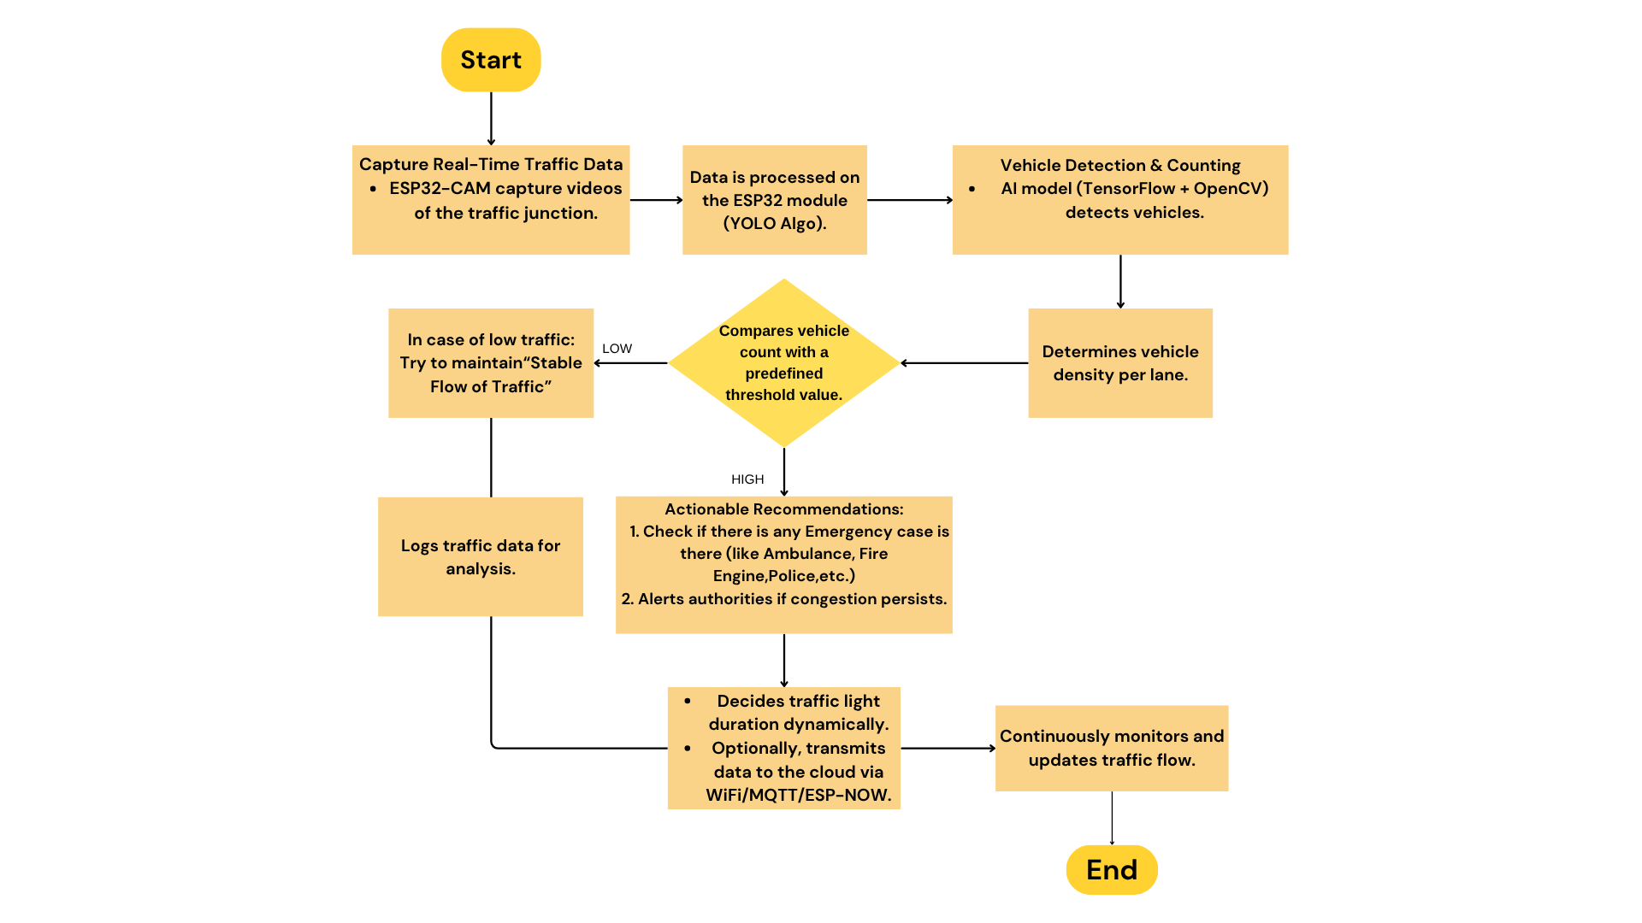
Fig. 4. Flowchart of working model
V. RESULTS
A smart traffic control system that automates signal lights based on vehicle density. A live graph interface showing real-time traffic volume trends. The adoption of AI Traffic Moderator brings about transformative changes in urban traffic management. In cities where traffic density overwhelms, AI becomes the green light toward smoother mobility. Faster traffic movement and less crowding are one of the main results of AI traffic moderators. Our system uses real-time video analysis with YOLO, which divides frames into grid cells to detect vehicles depending on the traffic density. It controls the signal changing green during heavy traffic which reduces delays and improves the flow.

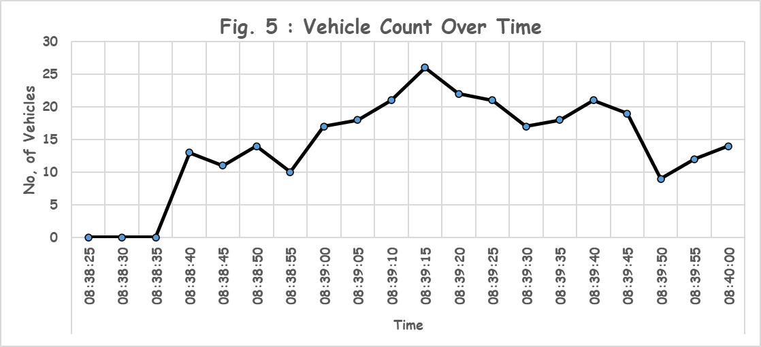Fig. 5. Graphical representation of dynamic traffic density

Fig.5 illustrates the real time vehicle count which is recorded for a short interval. The x-axis reflects the time while the y-axis represents the vehicle count using the YOLO algorithm. The graph initially starts with 0 peaks to 24 and then fluctuates. Depending on such shifts it makes appropriate changes in the signals.

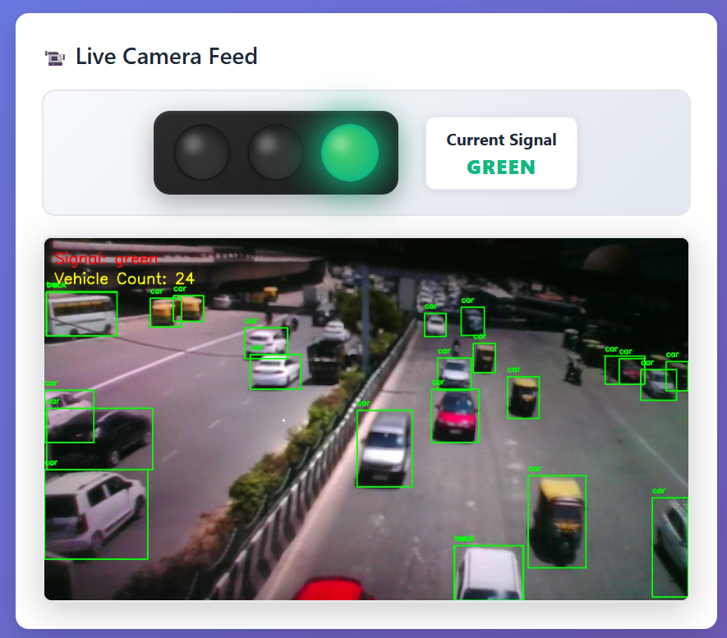
Fig. 6 Live Traffic feed portal

Fig. 6 depicts the count of vehicles and depending on the count the signal is adjusted automatically. The YOLO algorithm has detected and labelled vehicles (car, trucks) with green bounding boxes. The signal activates the green light.

The proposed AI-based traffic management system was evaluated using real-time video input and simulated traffic scenarios to analyse its performance in terms of detection accuracy, processing speed, and efficiency in traffic signal control.
A. Detection Accuracy
The YOLO-based object detection model demonstrated high accuracy in identifying vehicles such as cars, bikes, and trucks under varying traffic conditions. The system achieved an approximate detection accuracy of 90%, depending on lighting and traffic density. The use of Non-Maximum Suppression (NMS) ensured minimal duplicate detections and improved overall reliability.
B. Processing Speed
The system operates in real-time with an average processing speed of 20 frames per second (FPS) on a standard computing device. This ensures minimal delay between video input and signal decision, making the system suitable for real-world deployment in dynamic environments.
C. Traffic Signal Optimization Efficiency
The adaptive signal control mechanism significantly improved traffic flow by dynamically adjusting signal timings based on vehicle count:
- Reduced average waiting time at signals by approximately 30%
- Improved traffic clearance rate during peak hours
- Efficient handling of low-density traffic by avoiding unnecessary delays
D. Comparison with Traditional Systems
Parameter | Traditional System | Proposed AI System
Signal Timing | Fixed | Dynamic
Adaptability | Low | High
Vehicle Detection | Not Available | Real-time (YOLO)
Traffic Efficiency | Moderate | High
Waiting Time | High | Reduced (30%)
Table 4. Traditional vs Proposed Systems
From Table 4, the proposed system outperforms conventional fixed-timer traffic signals by providing real-time adaptability and improved traffic flow efficiency.
E. Visualization and Analysis
The system also generates real-time graphical representations of vehicle count over time, enabling better monitoring and analysis of traffic patterns. These visual insights help in understanding congestion trends and improving future system optimization.

VI. CONCLUSION
In conclusion, this research has presented a pioneering AI-enhanced traffic management system aimed at addressing the growing challenges of urban congestion. By integrating advanced object detection with adaptive signal control based on real-time traffic density, the system optimizes traffic flow, prioritizes emergency vehicles, and enhances safety for all road users. Making use of new technologies such as deep learning, IoT, V2I (vehicle-to-infrastructure) communication, and machine learning, the project demonstrates how intelligent decision-making can reduce the travel time, minimize fuel consumption, and improve the detection of pedestrians and cyclists. While challenges such as scalability, data security, and infrastructure integration remain, the findings highlight AI-driven traffic control as a transformative solution for future urban mobility. Hence, this work contributes to the goal of building safer, smarter transportation networks.

The future work of AI Traffic Moderator would focus on improving the system and making use of growing technologies. Key areas of development include:

Launching AI Models based on specific conditions: Every traffic zone functions differently depending on road size, peak hours, vehicle type and population density. By collecting location-based data the system can be trained for specific regions. This facilitates the AI model adapting to local traffic and improves the overall performance and accuracy.

Inspect Traffic Patterns and Maintaining Data Records for Auto-Training: By continuous monitoring and storing traffic data the system can identify the common patterns such as morning or evening rush hours, festival or weekend traffic changes. This can be used to retrain the AI model without any manual input. This would ensure better decision making.

Prioritizing Emergency Vehicles: Emergency vehicles can be equipped with RFID tags. Whenever an ambulance, fire truck or police vehicle is detected in the camera a separate green corridor can be provided to ensure fast and safe passage. This would help in improving the emergency response and save life.

AI-Based Accident Alert: AI can be trained further to detect accidents depending on the unusual traffic movement and collision pattern. Once the accident has been detected the system can send alerts to the traffic control center, emergency services using APIs or smart city networks.

References
[1] R. Bajaj, “AI for traffic management,” Delhi Skill and Entrepreneurship University, Mar. 2023.
[2] D. S. Shelar et al., “AI enhanced traffic management system,” Computer Research and Development, vol. 24, no. 6, 2024.
[3] F. Sultana et al., “Smart traffic management system for efficient mobility and emergency response,” in Proc. Int. Conf. Knowledge Engineering and Communication Systems (ICKECS), 2024.
[4] C. H. Genitha et al., “AI based real-time traffic signal control system using machine learning,” in Proc. 4th Int. Conf. Electronics and Sustainable Communication Systems (ICESC), 2023, pp. 1613–1618.
[5] S. F. Nasim et al., “Implementation of AI in traffic management: Need, current techniques and challenges,” Pakistan Journal of Scientific Research, vol. 3, no. 1, pp. 20–25, Oct. 2023.
[6] R. Chavan et al., “Comprehensive review on intelligent traffic management system in India,” in Proc. 8th Int. Conf. Advanced Computing and Communication Systems (ICACCS), 2023.
[7] C. R. Goenawan, “Autonomous smart traffic management system using artificial intelligence CNN and LSTM,” Korea Advanced Institute of Science and Technology, Feb. 2025.
[8] S. R. Karthik, P. Rajalakshmi, and M. Pradeep, “Deep learning-based traffic management system for smart cities,” IEEE Access, vol. 10, pp. 45678–45689, 2022.
[9] Y. Zhang, X. Wang, and L. Li, “Reinforcement learning-based traffic signal control: A review,” IEEE Transactions on Intelligent Transportation Systems, vol. 22, no. 4, pp. 1234–1245, 2021.
[10] A. Kumar, S. Singh, and R. Patel, “IoT and AI-based smart traffic management system,” International Journal of Advanced Computer Science and Applications (IJACSA), vol. 14, no. 5, pp. 210–218, 2023.
[11] J. Redmon and A. Farhadi, “YOLOv3: An incremental improvement,” arXiv preprint arXiv:1804.02767, 2018.
[12] A. Bochkovskiy, C. Y. Wang, and H. Y. M. Liao, “YOLOv4: Optimal speed and accuracy of object detection,” arXiv preprint arXiv:2004.10934, 2020.
[13] M. A. Rahman, M. S. Hossain, and G. Muhammad, “Intelligent traffic management system using deep learning,” IEEE Access, vol. 9, 2021.
[14] S. Wang, Y. Chen, and J. Li, “Edge computing for real-time traffic monitoring in smart cities,” IEEE Internet of Things Journal, vol. 10, no. 3, pp. 2345–2356, 2023.
[15] X. Ma, Z. Tao, Y. Wang, H. Yu, and Y. Wang, “Long short-term memory neural network for traffic speed prediction,” IEEE Transactions on Intelligent Transportation Systems, vol. 18, no. 10, pp. 2733–2742, 2017.

